The Gazette of the Democratic Socialist Republic of Sri Lanka EXTRAORDINARY
No. 681/2 - TUESDAY, SEPTEMBER 24, 1991

(Published by Authority)

PART I: SECTION (I) GENERAL

Government Notifications

L.D.-B 3/87

THE SECURITIES AND EXCHANGE COMMISSION OF SRI LANKA ACT, No. 36 of 1987

REGULATIONS made by the Minister of Finance under Section 52 of the Securities and Exchange Commission Act, No. 36 of 1987 read with Section 31A of that Act.

D.B. WIJETUNGE Minister of Finance

Colombo 21.09.1991.

Regulations

- These Regulations may be cited as Securities and Exchange Commission (Unit Trust) Regulations, No. 01 of the 1991.

- A managing company intending to operate a unit trust shall make an application to the Commission in that behalf in the form as specified in Schedule I hereto, together with-

  - a fee of one hundred thousand rupees; and
  - the documents as set out in Schedule II hereto.

- A licence granted to operate a unit trust shall be in the form as specified in Schedule III hereto

- Where an application made to operate a unit trust is refused, the fee paid by such applicant shall be refunded less a sum of fifteen thousand rupees which shall be retained by the Commission to cover administrative expenditure incurred by the Commission.

- In these regulations the terms "managing company" "Commission" and "Unit Trust" shall have the same meaning as given in the Securities and Exchange Commission of Sri Lanka Act, No. 36 of 1987

SCHEDULE I

FORM OF APPLICATION

- Applicant's full registered name and any former names (if any).

- Date and place of incorporation of the applicant

(please attach the Certificate of Incorporation as Annexure 1)

- (a) If the applicant is incorporated outside Sri Lanka, has it registered with the Registrar of Companies in Sri Lanka?

(b) If yes, give details of registration (please attach a copy of the certificate of registration as Annexure 1).

- Addresses of the applicant's registered office and the principal place of business.

- Please provide details pertaining to each existing director of the applicant company in the format provided in Annexure 2.

- Please provide details relating to directors who held office as directors of the applicant company during the period of preceding 5 years from the date of this application in the format provided in Annexure 3.

- Please provide organizational chart of the company in the format provided in Annexure 4.

- Provide the Capital Structure of the Applicant Company:
Stated Capital Shareholders Funds:
Financial Year End (dd/mm):

- Please provide the following details of each of the applicant company's shareholders, who beneficially owns, directly or indirectly, 20% or more of the company's ordinary capital:

Name of shareholders | Residential address | Name of beneficiary* | No. of shares held | Shareholding Percentage
*if the registered shareholder named above is a trustee or nominee

- Give the following particulars of the ultimate holding company of the applicant company, if any:

  - Name:

  - Registered office:

  - Country of incorporation:

  - Nature of business:

  - Names of existing directors:

  - Names of substantial shareholders who beneficially own, directly or indirectly, 20% or more of the ordinary capital of the ultimate holding company.

Name of Shareholder | Percentage of shares held

- If the applicant company is part of a group of companies, please provide a family tree chart showing the group structure to which the applicant company belongs with percentage sizes of shareholdings in the format given in Annexure 5:

- Provide details pertaining to each subsidiary and associated company of the applicant company, if any, in the format given in Annexure 6.

- State the total amount of any charges created by the applicant company over its assets or any part of them.

- Has the applicant company ever been licensed, registered, authorised or otherwise permitted by law to carry on any trade, business or profession in place other than aforesaid?

If yes, please provide details in the format given in Annexure 7.

- Has the applicant company ever been refused the right or restricted in the right to carry on any trade, business or profession for which a specific licence, registration or other authority is required by law in any place?
If yes, give full details of name of organisation and reasons.

- Are there any disciplinary actions or proceedings pending against the applicant company in relation to any trade, business or profession carried on by it in any place?

If yes, give full details of name of organisation taking actions or proceedings, nature of disciplinary actions or proceedings and reasons.

- Is the applicant company a party in any civil litigation whether as a plaintiff, a defendant or otherwise, in Sri Lanka or elsewhere?

If yes, give the following information:-

  - Name of Plaintiff;

  - Name of Defendant;

  - Name of third party (if any)

  - Nature of Litigation;

  - Name and place of court where the proceedings commenced;

  - Court Reference (if any)

- Has the applicant company ever entered into any scheme of arrangement or any form of composition with its creditors?

If yes, give details of the arrangement of composition.

- Has a petition ever been presented for winding up the applicant company?

If yes, is it now pending or how was it disposed of?

- Has a receiver ever been appointed by the court to manage the affairs of the applicant company?

If yes, is the receiver still in possession of the applicant company's assets?

- Has the applicant company ever entered into any scheme of arrangement or any form of composition with its creditors?

If yes, give details of the arrangement of composition.

- Has a petition ever been presented for winding up the applicant company?

If yes, is it now pending or how was it disposed of?

- Has a receiver ever been appointed by the court to manage the affairs of the applicant company?

If yes, is the receiver still in possession of the applicant company's assets?

- Are there any unsatisfied judgement debts, or judgement or court orders for the payment of damages or other sums of money, whether in Sri Lanka or elsewhere, outstanding against the applicant company?

If yes, state amount and full details:

- Give the following details of each bank at which accounts will be kept in connection with the business of the applicant company.

(a) Name of Bank(s): ........................................................................................

(b) Address(es): ..............................................................................................
(c) Account Number(s): .....................................................................................
(d) Date of opening account(s): ..........................................................................

- Addresses of all premises at which any record or other document relating to the business is kept:

- Are these premises used partly or wholly for residential purposes?

- If yes, give details.

- Name of unit trust:

- Structure of the unit trust:

- Applicable law/date & country of incorporation:

- Quotation on any stock exchange and authorization granted by other regulatory bodies:

- Undertakings given to other regulatory bodies;

- Launch: date and place;

- Dealings: daily/weekly/other

- Valuation of Assets: daily/weekly/other

- Pricing: forward/historic/other

- Investment plans;

- Fee Structure

(a) Fee Structure -

- level of all charges payable by investor;

- level of all charges payable by the unit trust.

- For equity schemes -

  - investment objectives and borrowing powers;

- Minimum initial subscription and the minimum subsequent holding;

We confirm that the information supplied in this application and annexed is true and correct and a receipt bearing number ................ dated is attached in proof of payment of application fee.

.....................................................
Signature and name of applicant company

Seal of the applicant company

SCHEDULE II

LIST OF DOCUMENTS TO BE SUBMITTED WITH APPLICATION FORM

- A copy of the Trust Deed Annexure 8.

- A copy of the Explanatory Memorandum/offering document Annexure 9.

- A copy of the last audited accounts and balance sheet or if applicant is a new company, latest available audited interim financial statements Annexure 10.

- A copy of the trustee's audited financial annual report Annexure 11.
(This document need not be submitted if a company has not completed one year of operation).

- A copy of the trustee's parent's annual audited financial statement Annexure 12.

- Application form for the unit holders Annexure 13.

- A document containing particulars of business/investment plans Annexure 14.

- Declaration by way of an Affidavit by Directors, Key Management Personnel and Persons dealing with clients Annexure 15.

- Declaration required from the Applicant Annexure 16.

SCHEDULE III

LICENCE TO A MANAGING COMPANY TO OPERATE A UNIT TRUST

The Securities and Exchange Commission of Sri Lanka, having considered the application for the grant of a licence made under section 31A of the Securities and Exchange Commission of Sri Lanka Act No. 36 of 1987 by…..of…………., on …………, hereby grants in the exercise of the powers conferred upon it by that section…….. a licence to the said Managing Company Company operate .................... Unit Trust from ............. 19 ...

...................................................
Chairman

Seal ...................................................
Director-General

Dated this ............ day of .......... 19 ....

GRANT OF A LICENCE TO OPERATE A UNIT TRUST

ANNEXURE | DOCUMENT TITLE | DOCUMENTS RELATED TO THE DOCUMENT TITLE
Annexure 1 | DOCUMENTS ON INCORPORATION | - Memorandum/Articles of Association  - Certificate of Incorporation/Certificate of Registration  - Certified copy of the Annual Return (Form 15)
Annexure 2 | INFORMATION ON DIRECTORS | - Status-chairperson/executive/non-executive  - Directorships in listed companies  - Directorships in Holding Company, Subsidiary Company/ies, Associate Company/ies  - Directorships in any other companies  - Directorships in any other company which has made a similar application to the SEC  - Directorships in any other company which has been licensed/registered by the SEC  - Shareholding in listed companies
Annexure 3 | INFORMATION ON DIRECTORS FOR THE PRECEEDING YEARS | - Name  - NIC  - Nationality  - Residential Address  - Period of Service  - Whether the person is currently involved with the company or a related party of the company in any capacity
Annexure 4 | ORGANIZATIONAL CHART | Organizational chart of the Company
Annexure 5 | GROUP STRUCTURE | Tree diagram of:  - group structure,  - percentage of shareholding of each group member  - principal business activities of each group member
Annexure 6 | RELATED COMPANIES | Details of;  - Holding Company  - Subsidiary Companies  - Associate Companies  - Partnerships
Annexure 7 | LICENSE/REGISTRATION STATUS OF ANY OTHER REGULATED ACTIVITIES | License/Registration status of any other regulated activities and the respective regulatory authority
Annexure 8 | TRUST DEED | - Copy of the Trust Deed  - Trustee approval letter on the Trust Deed.
Annexure 9 | EXPLANATORY MEMORANDUM (EM) | - Copy of the EM  - Trustee approval letter on the EM
Annexure 10 | AUDITED FINANCIALS | - Audited Financial Statements  - Statement of Profit or Loss and other comprehensive income  - Statement of financial position  - Cash flow statement  - Statement of changes in equity  - Notes to the financial statements  - Independent Auditors Report
Annexure 11 | TRUSTEE’S AUDITED FINANCIAL REPORT | - Trustee’s Audited Financial Statements  - Confirmation on the appointment of the Auditor for the Unit Trust by the Trustee
Annexure 12 | TRUSTEE’S PARENT’S ANNUAL AUDITED FINANCIAL STATEMENT | - Audited Financial Statements of the Trustee’s Parent Company
Annexure 13 | APPLICATION FORM FOR THE UNIT HOLDERS | - Application for the investors  Provided by the Managing Companies for the potential unit holders at the time of account opening
Annexure 14 | BUSINESS PLAN | - A comprehensive and detailed proposal inter alia the following:  - Business plan for the next five years with the execution plan and time lines  - financial projection  - Value proposition for the overall development of the capital market.  - operational and compliance manual including risk management framework  - Disaster recovery plan and the Business Continuity Plan
Annexure 15 | FITNESS AND PROPREITY AFFIDAVIT | - Declaration in the form of Affidavit with regard to Fitness and Propriety of Directors and Key Management Personnel (CEO, Compliance Officer) and Personnel dealing with clients.
Annexure 16 | DECLARATION OF DIRECTORS | Declaration by two Directors;  - that to the best of their knowledge no Director, Officer or Employee has been convicted of fraud or any criminal breach/charges or found guilty for contravening any provisions of the Act  - on the accuracy and completeness of the information submitted in the Application and the attached documents.

ANNEXURE 2

INFORMATION RELATING TO DIRECTORS

Name of the Director | Residential Address of the Director | Status (chairperson/executive/non-executive) | Date of appointment | Principal occupation | Professional qualifications | Directorships in listed companies | Directorships in Holding Company, Subsidiary/ies, Associate/s | Directorships in any other companies | Directorship in any other company which has made a similar application to the SEC | Directorship in any other company which has been licensed/registered by the SEC | Shareholding in listed companies

ANNEXURE 3

INFORMATION RELATING TO DIRECTORS OF THE PRECEEDING YEARS
Name | NIC No. | Nationality | Residential Address | Period of service | Whether the person is currently involved with the company or a related party of the company in any capacity

ANNEXURE 4
ORGANIZATIONAL CHART

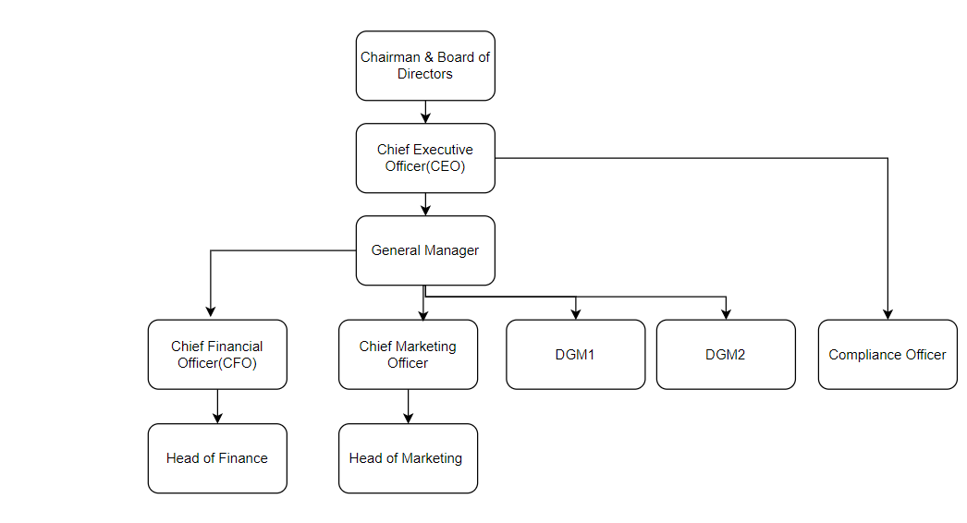

ANNEXURE 5
GROUP STRUCTURE

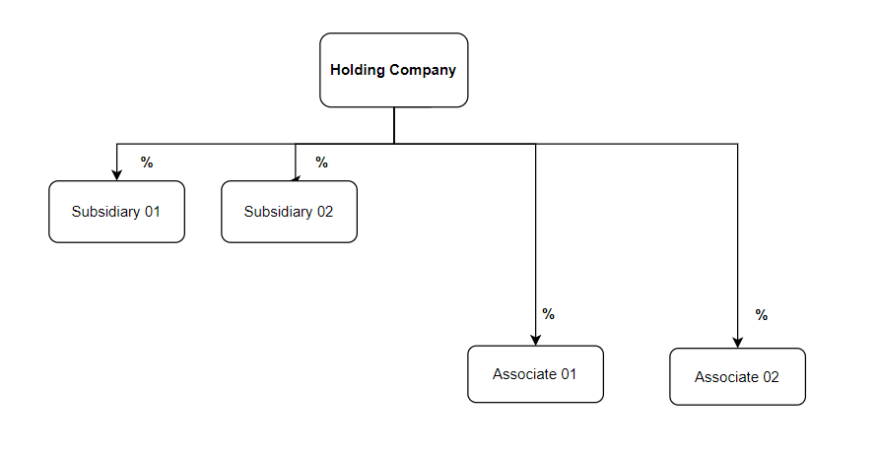

ANNEXURE 6

DETAILS PERTAINING TO RELATED COMPANIES

HOLDING COMPANY | SUBSIDIARY COMPANIES | ASSOCIATE COMPANIES | PARTNERSHIPS

ANNEXURE 7

DETAILS PERTAINING TO OTHER LICENSES/REGISTRATIONS/AUTHORIZATIONS/PERMITS

Name and place of licensing/registration body | Name under which the trade, business of profession to which such licence, registration, authorization or permit relates is/was carried on | Date of grant of License/registration /authorization/permits* | If license/registration/authorization/permit revoked, date and reasons of revocation
* attach copy of the relevant documents

SPECIMEN OF AN AFFIDAVIT

Affidavit

I, ___________________________________________________ [Full name] holder of NIC No. / Passport No. (In the case of a foreign national) ___________of __________________________ [Address], being a [Buddhist /Hindu do hereby solemnly, sincerely and truly declare and affirm] / [Christian/ Catholic/ Muslim make oath and swear as follows]:

- I am the [affirmant / deponent] above named.

- I affirm / state that I am a ____________ [Designation] of _________________________________ [Name of the applicant entity].

- I affirm / state that I possess the following academic and/ or professional qualification/s:

[State here the academic and/ or professional qualification/s]

- I affirm / state that there are no criminal / capital market cases pending against me in any court in Sri Lanka or abroad and that I have not been convicted of any criminal / capital market offence in Sri Lanka or abroad.

- I affirm / state that I have not been part of a body corporate which has been found guilty / held responsible by a court of law in Sri Lanka or abroad for the commission of any criminal offence/ capital market offence, proved to have been committed with the knowledge or involvement or negligence attributable to me.

- I affirm / state that I am not a person against whom an offence has been compounded or a fine has been imposed in terms of the Securities and Exchange Commission of Sri Lanka Act No. 36 of 1987 (as amended) during a period of three (3) years immediately preceding the date of this affidavit.

- I affirm / state that I am not a person/ director of a company or a shareholder in a position that exercises significant influence in a company that:

  - has been subject to any judgment debt or award in Sri Lanka or abroad, that remains unpaid in whole or in part; or

  - has in Sri Lanka or abroad filed for bankruptcy, winding-up, been declared bankrupt, had assets sequestered or been subjected to proceedings relating to any of the foregoing.

- I affirm / state that I am not an individual against whom an inquiry and/or investigation by the Securities and Exchange Commission of Sri Lanka/ the Colombo Stock Exchange/ any other regulatory/ supervisory authority/ professional body in Sri Lanka or abroad is presently pending, for the commission of any act which involves fraud, deceit or dishonesty or that a finding has been made by the Securities and Exchange Commission of Sri Lanka/ the Colombo Stock Exchange/ any other regulatory/ supervisory authority/ professional body in Sri Lanka or abroad that I have committed any act which involves fraud, deceit or dishonesty.

- I affirm / state that I have not been a director/ chief executive officer or chief financial officer of a company, partnership or other organization whose license or registration has been refused, suspended or cancelled by the Securities and Exchange Commission of Sri Lanka for violating any provision of the Securities and Exchange Commission of Sri Lanka Act No. 36 of 1987 (as amended), any Rules or Regulations made thereunder.

- I affirm / state that I have not been an individual who has been censured, disciplined, suspended or refused membership or registration by the Securities and Exchange Commission of Sri Lanka, the Colombo Stock Exchange or any other regulatory authority in Sri Lanka or abroad.

- I affirm / state that I have not been an individual who has been disqualified by the Securities and Exchange Commission of Sri Lanka, the Colombo Stock Exchange or any other regulatory body or professional body from serving as a director of a company, or has been dismissed or requested to resign from any position or office due to mismanagement of funds or the commission of a financial fraud.

- I affirm / state that no proceedings have been instituted in a Court of Law in Sri Lanka or abroad requesting that I be declared a bankrupt or that I have not been declared a bankrupt and that my assets have not been sequestered.

- I affirm / state that I have not contravened any written law enacted for the protection of the members of the public against financial loss by dishonesty, incompetence or malpractice.

- I affirm / state that I have not been declared as a person of unsound mind by a court of competent jurisdiction in Sri Lanka or abroad.

- I affirm / state that I have the competence/ expertise and experience in the nature of the business being conducted by the applicant.

- I affirm / state that I have not been engaged in or associated with any business practices in such manner as to cast doubt on my competence and/or soundness of judgment.

- I affirm / state that I have the appropriate range of skills and experience to understand, operate and manage the regulated activities/financial affairs of the applicant.

- I affirm / state that I have the technical knowledge and ability to perform the prescribed duties which I am engaged in, especially recognised professional qualifications and membership of relevant professional institutions.

- I affirm / state that all of the above are true and accurate to the best of my knowledge.
The averments contained herein were read over to the [affirmant/ deponent] who having understood the contents hereof and having accepted same as true,
[affirmed/ swore] to and placed his/her signature at …………. on
this …………… day of…………………

Affix stamps as
applicable

Before me

JUSTICE OF THE PEACE/
COMMISSIONER FOR OATHS

