APPLICATION FOR THE GRANT OF LICENCE AS A CREDIT RATING AGENCY

TO: CHAIRMAN
SECURITIES AND EXCHANGE COMMISSION OF SRI LANKA.

........................ (name of Applicant) of applies for licence as a Market Intermediary
under the category of Credit Rating Agency under the provisions of the Securities and Exchange Commission of Sri Lanka Act, No. 19 of 2021 and hereby undertakes, that in the event licence is granted, to comply with the provisions of the SEC Act, Rules, Regulations and Determinations made thereunder from time to time.

- Registered name and address of the Applicant (please include mailing address if different):
........................................................................................................................…………….

- Telephone/Fax Nos.: ...................................................................................................….

- E-mail address: ..................................................................................................…………..

- Web-site of the Applicant: ………………………………………………………………………………………….

- State whether the Applicant is formed and registered under the Companies Act, No. 17 of 1982 or the Companies Act No. 07 of 2007 of Sri Lanka or is a Company incorporated outside Sri Lanka or formed in pursuance of any statute of any foreign country, Royal Charter or Letters Patent or a body corporate established by or under any written law with details relating thereto including the statute under which it is formed and/or registered and the date of such formation and/or registration:
....................................................................................................................………………..

- The Capital Structure of the Applicant Company:
Stated Capital Shareholder’s Funds:
Financial Year End (dd/mm):

....................................................................................................................………………..

- List of names of the Holding Companies, Subsidiary Companies, Associate Companies and Partnerships in which the Applicant has an interest (Annexure 1); and

  - a tree diagram depicting the following (Annexure 2):
    - group structure,
    - percentage of shareholding of each group member,
    - principal business activities of each group member, and

  - an organisational chart of the Company (Annexure 3).

- Information relating to Shareholders

Name of Shareholder | Percentage of Shareholding
1.
2.
3.
4.

- Information relating to Directors (Annexure 4)
Please provide details pertaining to the Directors in the format given in Annexure 4.

- State whether the Directors of the Applicant;
- have been declared bankrupt;
- have proceedings now pending in a Court of Law for any offence involving fraud or dishonesty; and
- have been persons, or Directors of a Company, whose licence as a Market Intermediary or as a Market Institution has been cancelled or suspended by the Securities and Exchange Commission of Sri Lanka.

- Are the Directors of the Applicant Company functioning in the capacity of Directors of any Listed Companies?

If so, please provide the names of the Listed Companies against the names of the particular Director (Annexure 4).

- Are the Directors of the Applicant Company also Directors of the Holding Company/Subsidiary/ Associates?

If so please provide the names of the Companies against the name of the director (Annexure 4)

- Are the Directors of the Applicant Company shareholders of Listed Companies?

If so, please provide the names of the Listed Companies against the name of the particular Director (Annexure 4).

- Do the Directors of the Applicant Company represent another company which has also made a similar application to the Securities and Exchange Commission of Sri Lanka to carry on the identical business as in the present application?

If so, please provide the name of the company against the name of the particular Director (Annexure 4).
- Are the Directors of the Applicant Company involved in any manner in another company which carries on any business which has been licensed by or has been registered with the Securities and Exchange Commission of Sri Lanka?

If so please provide the name of the company and the nature of business against the name of the particular Director (Annexure 4).

- Please provide information relating to Personnel involved in providing ratings in the format below;
(Please attach duly authenticated copies of certificates/documents to support same as Annexure 5 of the Application)

Names of Personnel | Designation/Position | Qualification and/or Experience
1.
2.
3.
4.

- Please provide information relating to the rating committee in the format given below;

Names of Committee Members | Designation/Position | Qualification and Experience
1.
2.
3.

- General Information
The Applicant:

  - Has there been any judgment by a court of law in respect of any findings of fraud or other dishonest act, misrepresentation, breach of contract, breach of fiduciary duty or professional negligence against it, in any criminal/civil proceedings, or are there any proceedings now pending in a court of law?

……………………………………………………………………………………………………………………………….. (if so, please provide details)

  - Has there been/is there a receiver and/or manager appointed in respect of any of the assets of the Applicant?

………………………………………………………………………………………………………………………………. (if so, please provide details)

  - Has there been/is there a Petition presented in a Court for its winding up?

………………………………………………………………………………………………………………………………. (if so, please provide details)

  - been subjected to any form of disciplinary proceedings or action by any professional or regulatory body?

………………………………………………………………………………………………………………………………. (if so, please provide details)

- Documents relating to Incorporation
The application comprises of the following documents which are duly authenticated as true copies of the original:

- copy of the Memorandum/Articles of Association or corresponding documents (Annexure 6).

- copy of the Certificate of Incorporation and the Certificate to Commence Business, if any, or corresponding documents (Annexure 7)

- Documents relating to Financials and Operational Requirements

- Audited Financial Statements (Annexure 8):
for the immediately preceding three years; or
in the event the Applicant has not been in business for three years latest available interim audited financial statements.
- Details of rating methodologies/criteria adopted by the Applicant (Annexure 9).

- Business relationships, ownership interests or any other financial interest between the Applicant or any other individual associated with the Applicant (Annexure 10).

- Licence/Registration status of any other regulated activities of the Applicant and the respective regulatory authority (Annexure 11).

- Declaration by way of an affidavit by directors, key management personnel and rating analysts (Annexure 12)
- Declarations Required from the Applicant (Annexure 13)
- Declaration by two Directors of the Applicant that to the best of their knowledge no Director, Officer or Employee of the Applicant has been convicted of fraud or criminal breach of trust or cheating or criminal misappropriation or declared bankrupt or found guilty of contravening any provisions of the SEC Act or any Rules or Regulations made under the SEC Act.
- Declaration by the Applicant that the promoters of the Applicant are persons of means and integrity and have special knowledge of matters which the Applicant may have to deal with as a Credit Rating Agency.
- Declaration by the Applicant that no Director of the Applicant is also a Director of a corporate entity or a business firm or a shareholder holding five per centum or more of any corporate entity or business firm or is in any other way interested in an entity subject to rating by the Applicant.
- Undertaking by the Applicant to ensure that no Director, Officer or Employee of the Applicant will communicate any information acquired by them for rating purposes, or in the course of such rating to any other person except when required under Law to do so.

- Bank Receipt/Cheque No. ...........dated.......................for Rs................is attached, being licence fees

We declare that all information provided herein is true and correct and that all attachments are individually certified as being true copies and correct.

NAME & SIGNATURE OF DIRECTOR NAME & SIGNATURE OF DIRECTOR/COMPANY SECRETARY

DATE

N. B. Section 103 (1) of the SEC Act requires a Market Intermediary that proposes to alter material particulars already furnished or undergoes or intends to alter the particulars specified in the application for a licence or the renewal of a licence, to inform the Commission and obtain its prior consent before such alteration or change is effected.

GRANT OF LICENCE AS A CREDIT RATING AGENCY

ANNEXURE | DOCUMENT TITLE | DOCUMENTS RELATED TO THE TITLE DOCUMENT
Annexure 1 | RELATED COMPANIES | Details of;  - Holding Company  - Subsidiary companies  - Associate companies  - partnerships
Annexure 2 | GROUP STRUCTURE | Tree diagram of:  - group structure,  - percentage of shareholding of each group member  - principal business activities of each group member
Annexure 3 | ORGANIZATIONAL CHART | Organizational chart of the Company
Annexure 4 | INFORMATION RELATING TO DIRECTORS | - Name and address  - Status-chairman/executive/non-executive  - Directorship in listed companies  - Shareholding in listed companies  - Directorship in Holding company, subsidiary company/ies, associate company/ies  - Directorship in any other company which has made a similar application to the SEC  - Directorship in any other company which has been licensed by the SEC
Annexure 5 | PERSONNEL INVOLVED IN PROVIDING RATINGS | - Certificates, documents to support qualifications/experience
Annexure 6 | MEMORANDUM/ARTICLES OF ASSOCIATION | Memorandum/Articles of Association
Annexure 7 | CERTIFICATE OF INCORPORATION AND COMMENCE BUSINESS | Certificate of Incorporation and Certificate to commence business
Annexure 8 | AUDITED FINANCIAL STATEMENTS | - Audited financials for the preceding 3 years including;  - Statement of Profit or Loss and other comprehensive income  - Statement of financial position  - Statement of changes in equity  - Cash flow statement  - Notes to the financial statements  - Independent Auditor’s report  - If not in operation for 3 years –latest available interim audited financial statements
Annexure 9 | RATING METHODOLOGY | Rating methodology/criteria details
Annexure 10 | BUSINESS RELATIONSHIPS | - Business relationships  - ownership interests  - any other financial interest  between the applicant and any other company/individual
Annexure 11 | LICENCE/REGISTRATION STATUS OF ANY OTHER REGULATED ACTIVITIES | Licence/Registration status of any other regulated activities and the respective regulatory authority.
Annexure 12 | FITNESS AND PROPRIETY AFFIDAVITS | Declaration in the form of an Affidavit with regard to Fitness and Propriety of Directors, Key Management Personnel (CEO, Compliance Officer), rating analysts and members of the rating committee.
Annexure 13 | DECLARATIONS BY DIRECTORS/APPLICANT | - Declaration to be submitted by two directors  - Declarations to be submitted by the Applicant

ANNEXURE 1

RELATED COMPANIES

HOLDING COMPANY | SUBSIDIRARY COMPANIES | ASSOCIATE COMPANIES | PARTNERSHIPS

ANNEXURE 2

GROUP STRUCTURE

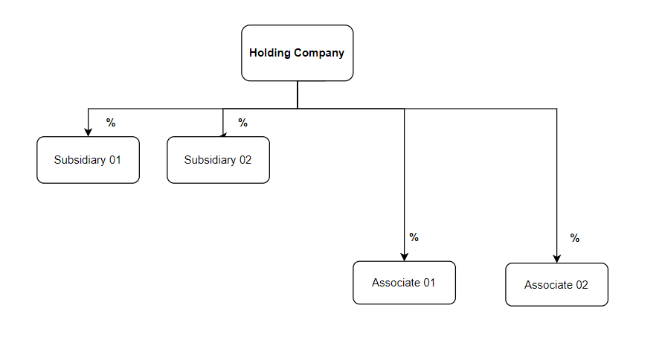

ANNEXURE 3

ORGANIZATIONAL CHART

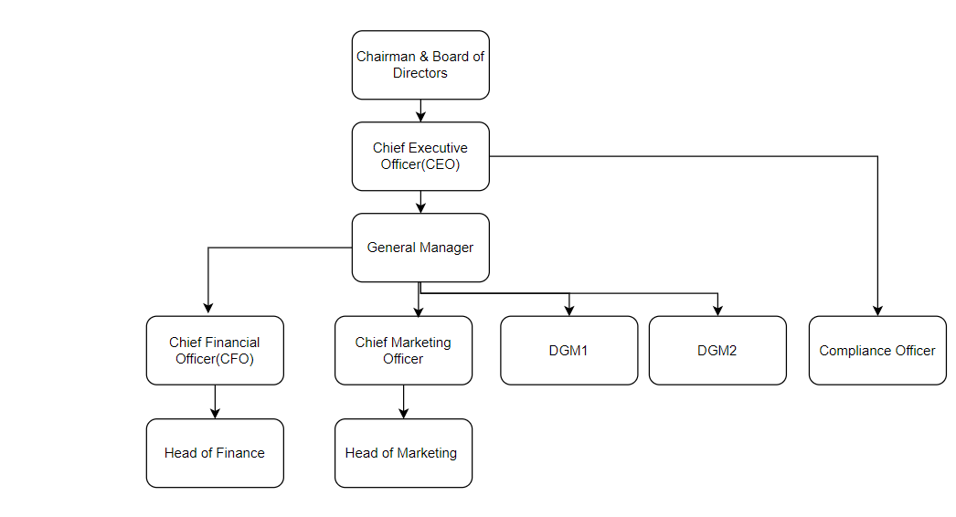

ANNEXURE 4

INFORMATION RELATING TO DIRECTORS

Name of the Director | Residential Address of the Director | Status (chairperson/executive/non-executive) | Directorship in listed companies | Shareholding in listed companies | Directorship in Holding Company, Subsidiary/ies, Associate/s | Directorship in any other company which has made a similar application to the SEC | Directorship in any other company which has been licensed by the SEC

SPECIMEN OF AN AFFIDAVIT

Affidavit

I, ___________________________________________________ [Full name] holder of NIC No. / Passport No. (In the case of a foreign national) ___________of __________________________ [Address], being a [Buddhist /Hindu/ Muslim do hereby solemnly, sincerely and truly declare and affirm] / [Christian/ Catholic make oath and swear as follows]:

- I am the [affirmant / deponent] above named.

- I affirm / state that I am a ____________ [Designation] of _________________________________ [Name of the applicant entity].

- I affirm / state that I possess the following academic and/ or professional qualification/s:

[State here the academic and/ or professional qualification/s]

- I affirm / state that there are no criminal / capital market cases pending against me in any court in Sri Lanka or abroad and that I have not been convicted of any criminal / capital market offence in Sri Lanka or abroad.

- I affirm / state that I have not been part of a body corporate which has been found guilty / held responsible by a court of law in Sri Lanka or abroad for the commission of any criminal offence/ capital market offence, proved to have been committed with the knowledge or involvement or negligence attributable to me.

- I affirm / state that I am not a person against whom an offence has been compounded or a fine has been imposed in terms of the Securities and Exchange Commission of Sri Lanka Act, No. 19 of 2021 during a period of three (3) years immediately preceding the date of this affidavit.

- I affirm / state that I am not a person/ director of a company or a shareholder in a position that exercises significant influence in a company that:

  - has been subject to any judgment debt or award in Sri Lanka or abroad, that remains unpaid in whole or in part; or

  - has in Sri Lanka or abroad filed for bankruptcy, winding-up, been declared bankrupt, had assets sequestered or been subjected to proceedings relating to any of the foregoing.

- I affirm / state that I am not an individual against whom an inquiry and/or investigation by the Securities and Exchange Commission of Sri Lanka/ the Colombo Stock Exchange/ any other regulatory/ supervisory authority/ professional body in Sri Lanka or abroad is presently pending, for the commission of any act which involves fraud, deceit or dishonesty or that a finding has been made by the Securities and Exchange Commission of Sri Lanka/ the Colombo Stock Exchange/ any other regulatory/ supervisory authority/ professional body in Sri Lanka or abroad that I have committed any act which involves fraud, deceit or dishonesty.

- I affirm / state that I have not been a director/ chief executive officer or chief financial officer of a company, partnership or other organization whose license or registration has been refused, suspended or cancelled by the Securities and Exchange Commission of Sri Lanka for violating any provision of the Securities and Exchange Commission of Sri Lanka Act, No. 19 of 2021, any Rules or Regulations made thereunder.

- I affirm / state that I have not been an individual who has been censured, disciplined, suspended or refused membership or registration by the Securities and Exchange Commission of Sri Lanka, the Colombo Stock Exchange or any other regulatory authority in Sri Lanka or abroad.

- I affirm / state that I have not been an individual who has been disqualified by the Securities and Exchange Commission of Sri Lanka, the Colombo Stock Exchange or any other regulatory body or professional body from serving as a director of a company, or has been dismissed or requested to resign from any position or office due to mismanagement of funds or the commission of a financial fraud.

- I affirm / state that no proceedings have been instituted in a Court of Law in Sri Lanka or abroad requesting that I be declared a bankrupt or that I have not been declared a bankrupt and that my assets have not been sequestered.

- I affirm / state that I have not contravened any written law enacted for the protection of the members of the public against financial loss by dishonesty, incompetence or malpractice.

- I affirm / state that I have not been declared as a person of unsound mind by a court of competent jurisdiction in Sri Lanka or abroad.

- I affirm / state that I have the competence/ expertise and experience in the nature of the business being conducted by the applicant.

- I affirm / state that I have not been engaged in or associated with any business practices in such manner as to cast doubt on my competence and/or soundness of judgment.

- I affirm / state that I have the appropriate range of skills and experience to understand, operate and manage the regulated activities/financial affairs of the applicant.

- I affirm / state that I have the technical knowledge and ability to perform the prescribed duties which I am engaged in, especially recognised professional qualifications and membership of relevant professional institutions.

- I affirm / state that all of the above are true and accurate to the best of my knowledge.
The averments contained herein were read over to the [affirmant/ deponent] who having understood the contents hereof and having accepted same as true,
[affirmed/ swore] to and placed his/her signature at …………. on
this …………… day of…………………

Affix stamps as
applicable

Before me

JUSTICE OF THE PEACE/
COMMISSIONER FOR OATHS

