APPLICATION FOR THE GRANT OF LICENCE AS AN UNDERWRITER

TO: CHAIRMAN
SECURITIES AND EXCHANGE COMMISSION OF SRI LANKA.

........................ (name of Applicant) of applies for licence as a Market Intermediary in the capacity of an Underwriter under the provisions of the Securities and Exchange Commission of Sri Lanka Act, No. 19 of 2021 (the SEC Act) and hereby undertakes, that in the event licence is granted, to comply with the provisions of the SEC Act, Rules, Regulations and Determinations made thereunder from time to time.

- Registered name and address of the Applicant (please include mailing address if different):
........................................................................................................................…………………………

- Telephone/ Fax Nos.: ...................................................................................................…………………….

- E-mail address: ..................................................................................................………………………………

- Web-site of the Applicant: …………………………………………………………………………………………………………………

- Details of the contact person:
    - Name and designation: ……………………………………………….
    - Email address: …………………………………………………………….
    - Telephone No.: ……………………………………………………………

- Name to be appeared on the certificate: ……………………………………………………………………………………….

- Address to be appeared on the certificate: ……………………………………………………………………………………

- State whether the Applicant is formed and registered under the Companies Act, No. 17 of 1982 or the Companies Act No. 07 of 2007 of Sri Lanka or is a Company incorporated outside Sri Lanka or formed in pursuance of any statute of any foreign country, Royal Charter or Letters Patent or a body corporate established by or under any written law with details relating thereto including the statute under which it is formed and/or registered and the date of such formation and/or registration:
..................................................................................................................……………………………….

- The Capital Structure of the Applicant:
Stated Capital (Rs.):
Shareholders Funds (Rs.):
Financial Year End (dd/mm):

- List of names of the Holding Companies, Subsidiary Companies, Associate Companies and Partnerships and Joint Ventures in which the Applicant has an interest (Annexure 1); and

- following particulars of the ultimate holding company of the Applicant, if any:
- Name: ……………………………………………………………………………………
- Registered office: …………………………………………………………………….
- Country of incorporation: ………………………………………………………….
- Nature of business: …………………………………………………………………
- Names of existing directors: ……………………………………………………..
- Names of substantial shareholders who beneficially own, directly or indirectly, 20% or more of the ordinary capital of the ultimate holding company.

Name of Shareholder | Percentage of shares held

- a tree diagram depicting the following (Annexure 2);
    - group structure,
    - percentage of shareholding of each group member,
    - principal business activities of each group member, and

- organisational chart of the Applicant including names and designations, as at the date of application (Annexure 3).

Shareholding Composition*

Shareholders
Individual | Ordinary |  | Preference |  | Others
 | No. | % | No. | % | No. | %
Corporation | Ordinary |  | Preference |  | Others
 | No. | % | No. | % | No. | %
*In the event the Applicant is a listed entity, please provide details of the top 10 shareholders.

Information relating to Directors of the Applicant
(Please provide details pertaining to Directors of the Applicant in the format given in (Annexure 4)).

- Are the Directors of the Applicant, functioning in the capacity of Directors of any Listed Companies?

(If so, please provide the names of the Listed Companies against the names of the particular Director).

- Are the Directors of the Applicant, also Directors of the Holding Company/ Subsidiary/ Associates/ Partnerships/ Joint Ventures?

(If so please provide the names of the Companies against the name of the director).

- Are the Directors of the Applicant, shareholders of Listed Companies?

(If so, please provide the names of the Listed Companies against the name of the particular Director).

- Are the Directors of the Applicant, directors of another company which has also made a similar application to the Securities and Exchange Commission of Sri Lanka to carry on the identical business as in the present application?

(If so, please provide the name of the company against the name of the particular Director).

- Are the Directors of the Applicant, directors of another company which carries on any business which has been licensed by the Securities and Exchange Commission of Sri Lanka?

(If so please provide the name of the company and the nature of business against the name of the particular Director).

- Whether the Directors of the Applicant are/ have been directors of a company that has applied for approval from the SEC to be licensed as a Market Institution/ Intermediary and has been rejected by the SEC?
(If so, please provide details including the name of the company and the type of rejected licence application against the name of the particular Director).

- Whether the Directors of the Applicant are/ have been directors of a company licensed by the SEC which has failed to cease its business operations or to renew its licence in terms of the applicable Rules of the SEC?
(If so, please provide details including the name of the company and the type of licence held against the name of the particular Director).

- Whether any Director of the Applicant,

- has been convicted, whether within or outside Sri Lanka of an offence involving fraud or dishonesty or the conviction of which involved a finding that he/ she has acted fraudulently or dishonestly;

- has been subjected to any administrative sanction under the SEC Act;

- has been convicted or has been compounded of an offence for which he/ she has been charged under the SEC Act or under the laws governing securities outside Sri Lanka;

- has contravened any provision made under any law whether within or outside Sri Lanka enacted for protecting members of the public against financial loss, due to dishonesty, incompetence or malpractice by persons, concerned in the provision of financial services or the management of companies or against financial loss due to the conduct of discharged or undischarged bankrupts; and

- is an undischarged bankrupt whether within or outside Sri Lanka.

- General Information regarding the Applicant

- Has there been any judgment by a court of law in respect of any findings of fraud or other dishonest act, misrepresentation, breach of contract, breach of fiduciary duty or professional negligence against the Applicant, in any criminal/civil proceedings, or are there any proceedings now pending in a court of law?
………………………………………………………………………………………………………………………………………….
(if so, please provide details)

- Has there been/is there a receiver/ manager/ liquidator or an equivalent person appointed in respect of any of the assets of the Applicant?
………………………………………………………………………………………………………………………………………….
(if so, please provide details)

- Is the Applicant in the course of being wound up or otherwise dissolved or an undischarged bankrupt?
………………………………………………………………………………………………………………………………………….
(if so, please provide details)

- Has there been/is there a judgment debt against the Applicant which has not been satisfied in whole or in part?
………………………………………………………………………………………………………………………………………….
(if so, please provide details)

- Has the Applicant entered into a compromise or a scheme of arrangement with its creditors?
………………………………………………………………………………………………………………………………………….
(if so, please provide details)

- Has the Applicant been subjected to any form of disciplinary proceedings or action by any professional or regulatory body?
………………………………………………………………………………………………………………………………………….
(if so, please provide details)
- Has the Applicant applied for approval from the SEC to be licensed as a Market Intermediary and been rejected by the SEC?
…………………………………………………………………………………………………………………………………………….
(If so, please provide details includes the name of the company and the type of rejected licence application against the name of the particular Director).

- Whether the Applicant is a company licensed by the SEC which has failed to cease its business operations or to renew its licence in terms of the applicable Rules of the SEC?
…………………………………………………………………………………………………………………………………………….
(If so, please provide details includes the name of the company and the type of rejected licence application against the name of the particular Director).

- Documents relating to Incorporation

The application comprises of the following documents which are duly authenticated as true copies of the originals.
- Copy of the Memorandum/ Articles of Association or corresponding documents (Annexure 5);
- Copy of the Certificate of Incorporation and the Certificate to Commence Business, if any, or corresponding documents (Annexure 6).

- Documents Relating to Financial and Operational Requirements

- Licence status of any other regulated activities of the Applicant and the respective regulatory authority (Annexure 7)
- Audited financial statements (for the immediately preceding three (3) years or in the event the Applicant has not been in business for three (3) years the latest interim audited financial statements (Annexure 8);
- Details on other business activities of the Applicant (Annexure 9);
- Documents outlining the business model to carry on the functions of an Underwriter (Annexure 10);
- Declaration by the Applicant as per the specimen contained in Schedule I of the Rules Applicable to Underwriters (Annexure 11);
- A copy of the internal compliance manual as set out in Schedule IV of the Rules Applicable to Underwriters (Annexure 12);
- Documentation in support of measures taken to acquire an information processing system as per Rules 24 of the Rules Applicable to Underwriters (Annexure 13);
- Documentation in support of steps taken to recruit adequate human resources to effectively discharge the obligations in keeping with the identified organizational structure of the Applicant (Annexure 14)

- Processing fees
Cheque No. ...........dated .......................for Rs................is attached, being processing fees.
(If the payment was done by a fund transfer, attach the scanned copy of the fund transfer receipt as proof of payment)

We declare that all information provided herein is true and correct and that all attachments are individually certified as being true copies and correct.

………………………………………….. …………………………………………………….
NAME & SIGNATURE OF DIRECTOR NAME & SIGNATURE OF DIRECTOR/COMPANY SECRETARY

DATE ………………..
GRANT OF LICENCE AS AN UNDERWRITER

ANNEXURE | DOCUMENT TITLE | DOCUMENTS RELATED TO THE TITLE DOCUMENT
Annexure 1 | RELATED COMPANIES | Details of;  - Holding Company  - Subsidiary Companies  - Associate Companies  - Partnerships  - Joint Ventures
Annexure 2 | GROUP STRUCTURE | Tree diagram of:  - Group Structure  - Percentage of shareholding of each group member  - Principal business activities of each group member
Annexure 3 | ORGANIZATIONAL CHART | Organizational Chart of the Company including names and designations of the responsible individuals
Annexure 4 | INFORMATION RELATING TO DIRECTORS | - Name and address  - Status-chairman/executive/non-executive  - Directorships in listed companies  - Shareholding in listed companies  - Directorships in Holding company, subsidiary company/ies, associate company/ies, partnerships & joint ventures  - Directorships in any other company which has made a similar application to the SEC  - Directorships in any other company which has been licensed by the SEC
Annexure 5 | MEMORANDUM/ARTICLES OF ASSOCIATION | Memorandum/ Articles of Association
Annexure 6 | CERTIFICATE OF INCORPORATION AND COMMENCE BUSINESS | Certificate of Incorporation and Certificate to commence business
Annexure 7 | LICENCE STATUS OF ANY OTHER REGULATED ACTIVITY | Licence status of any other regulated activities and the respective regulatory authority
Annexure 8 | AUDITED FINANCIAL STATEMENTS | - Audited Financial Statements for the preceding 3 years including  - Statement of Profit or Loss and other comprehensive income  - Statement of financial position  - Statement of changes in equity  - Cash flow statement  - Notes to the financial statements  - Independent Auditor’s report  - If not in operation for 3 years, latest available interim audited financial statements
Annexure 9 | OTHER BUSINESS ACTIVITIES | - Details on other business activities of the Applicant
Annexure 10 | BUSINESS MODEL | A comprehensive and detailed proposal including inter alia the following:  - Documents outlining the business model to carry on the functions of an Underwriter  - Value proposition for the overall development of the capital market
Annexure 11 | DECLARATION BY THE APPLICANT | This must be as per the specimen contained in Schedule I of the Rules Applicable to Underwriters
Annexure 12 | INTERNAL COMPLIANCE MANUAL | This must be as specified in Schedule IV of the Rules Applicable to Underwriters
Annexure 13 | INFORMATION PROCESSING SYSTEM | Documentation in support of measures taken to acquire an information processing system as per Rules 21 and 22 of the Rules Applicable to Underwriters
Annexure 14 | HUMAN RESOURCES | Documentation in support of steps taken to recruit adequate human resources to effectively discharge the obligations in keeping with the identified organizational structure of the Applicant

ANNEXURE 1

RELATED COMPANIES

HOLDING COMPANY | SUBSIDIARY COMPANIES | ASSOCIATE COMPANIES | PARTNERSHIPS | JOINT VENTURES

ANNEXURE 2

GROUP STRUCTURE

Principal Business Activity
%
Holding Company
Subsidiary 02

Associate 02

Associate 01
Subsidiary 01

%

%

%

%

Principal Business Activity
Principal Business Activity
Principal Business Activity
Principal Business Activity

ANNEXURE 3

ORGANIZATIONAL CHART

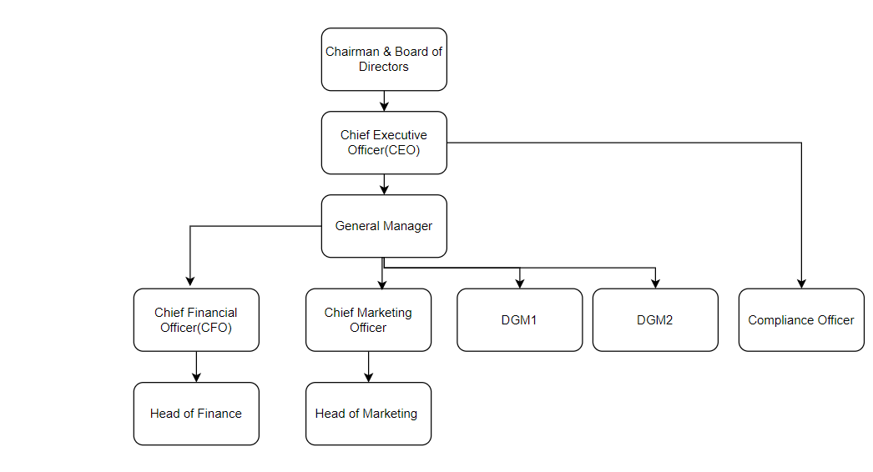

ANNEXURE 4

INFORMATION RELATING TO DIRECTORS

Name in Full | NIC/ Passport No. | Residential Address | Status (chairperson/executive/non-executive) | Directorship in listed companies | Shareholding in listed companies | Directorship in Holding Company, Subsidiary/ies, Associate/s  Partnerships,  Joint Ventures | Directorship in any other company which has made a similar application to the SEC | Directorship in any other company which has been licensed by the SEC

ANNEXURE 11
Declaration by the Applicant

To: Chairman
Securities and Exchange Commission of Sri Lanka
Level 28 & 29, East Tower
World Trade Center
Echelon Square, Colombo 01, Sri Lanka.

In consideration of being licensed/registered to operate as (category of the market intermediary), we (name of the applicant entity) being duly incorporated and having our registered office/ principal place of business at (address)….. hereby undertake and agree:

- to be licensed at the sole discretion of the SEC and for such period as may be determined by the SEC; and

- to be bound by the applicable Laws, Rules, Regulations and Directives of the Securities and Exchange Commission of Sri Lanka (SEC) as amended or replaced from time to time.

We further declare that no finding has been made against the Applicant/the Applicant entity by a court of law in Sri Lanka or abroad for the commission of any criminal offence/ capital market offence or any other act which involves fraud, deceit, dishonesty, misrepresentation, breach of contract or breach of fiduciary duty.

Given under the Common Seal of the Entity on this …. day of …. in the presence of

……………………….
(Name) Director

………………………..
(Name) Director/Secretary
Or,
Signed by the duly authorized signatories of the Entity on this …. day of …..

…………………………
(Name) Authorized Signatory

Note: Please attach a certified true copy of the Board Resolution/Power of Attorney in proof of such authority.

