APPLICATION FOR THE RENEWAL OF LICENCE AS A STOCK BROKER/STOCK DEALER

TO: CHAIRMAN
SECURITIES AND EXCHANGE COMMISSION OF SRI LANKA.

........................ (name of Applicant) of.………………applies for renewal of licence as a Market Intermediary in the capacity of a Stock Broker/Stock Dealer under the provisions of the Securities and Exchange Commission of Sri Lanka Act, No. 19 of 2021 (the SEC Act) and hereby undertakes, that in the event renewal of licence is granted, to comply with the provisions of the SEC Act, Rules, Regulations and Determinations made thereunder from time to time.

- Registered name and address of the Applicant (please include mailing address if different):
..................................................................................................................………………………….
- Is the Applicant incorporated in Sri Lanka? (state date of incorporation)
…………………………………………………………………………………………………………………………………………..
- Telephone/Fax No.: ...................................................................................................…………………
- E-mail address: ..................................................................................................………………………..
- Web-site of the Applicant: ………………………………………………………………………………………………………..
- Details of the contact person:
    - Name and designation: ………………………………………………………………………….........
    - Email address: ……………………………………………………………………………………………..
    - Telephone No.: …………………………………………………………………………………………….

- State whether the Applicant is formed and registered under the Companies Act, No. 17 of 1982 or the Companies Act No. 07 of 2007 of Sri Lanka or is a Company incorporated outside Sri Lanka or formed in pursuance of any statute of any foreign country, Royal Charter or Letters Patent or a body corporate established by or under any written law with details relating thereto including the statute under which it is formed and/or registered and the date of such formation and/or registration:
..................................................................................................................……………...............

- The Capital Structure of the Applicant:
Stated Capital (Rs.):
Shareholders’ Funds (Rs.):
Financial Year End (dd/mm):

- List of names of the Holding Companies, Subsidiary Companies, Associate Companies and Partnerships and Joint Ventures in which the Applicant has an interest and control (Annexure 1); and

- a tree diagram depicting the following (Annexure 2);
    - group structure,
    - percentage of shareholding of each group member,
    - principal business activities of each group member, and

- organisational chart of the Applicant including names and designations, as at the date of application (Annexure 3).

Shareholding Composition* as at ………………………………………………..

Shareholders
Individual | Ordinary |  | Preference |  | Others
 | No. | % | No. | % | No. | %
Corporation | Ordinary |  | Preference |  | Others
 | No. | % | No. | % | No. | %
*In the event the Applicant is a listed company, please provide details of the top 10 shareholders.

- Information Relating to Directors of the Applicant

(Please provide details pertaining to Directors of the Applicant in the format given in (Annexure 4).

- Are the Directors of the Applicant functioning in the capacity of Directors of any Listed Companies?

(If so, please provide the names of the Listed Companies against the names of the particular Director).

- Are the Directors of the Applicant also Directors of the Holding Company/ Subsidiary/ Associates/Joint Ventures?

(If so please provide the names of the Companies against the name of the director).

- Are the Directors of the Applicant shareholders of Listed Companies?

(If so, please provide the names of the Listed Companies against the name of the particular Director).

- Are the Directors of the Applicant directors of another company which has also made a similar application to the Securities and Exchange Commission of Sri Lanka to carry on the identical business as in the present application?

(If so, please provide the name of the company against the name of the particular Director).

- Are the Directors of the Applicant directors of another company which carries on any business which has been licensed by the Securities and Exchange Commission of Sri Lanka?

(If so please provide the name of the company and the nature of business against the name of the particular Director).

- Whether any Director of the Applicant

- has been convicted, whether within or outside Sri Lanka of an offence involving fraud or dishonesty or the conviction of which involved a finding that he/ she has acted fraudulently or dishonestly;
- has been subjected to any administrative sanction under the SEC Act;

- has been convicted or has been compounded of an offence for which he/ she has been charged under the SEC Act or under the laws governing securities outside Sri Lanka;

- has contravened any provision made under any law whether within or outside Sri Lanka enacted for protecting members of the public against financial loss, due to dishonesty, incompetence or malpractice by persons, concerned in the provision of financial services or the management of companies or against financial loss due to the conduct of discharged or undischarged bankrupts; and

- is an undischarged bankrupt whether within or outside Sri Lanka.

General Information regarding the Applicant

  - Has there been any judgment by a court of law in respect of any findings of fraud or other dishonest act, misrepresentation, breach of contract, breach of fiduciary duty or professional negligence against the Applicant, in any criminal/civil proceedings, or are there any proceedings now pending in a court of law?
…………………………………………………………………………………………………………………………….. (if so, please provide details)

  - Has there been/is there a receiver/ manager/ liquidator or an equivalent person appointed in respect of any of the assets of the Applicant?
………………………………………………………………………………………………………………………………. (if so, please provide details)

  - Is the Applicant in the course of being wound up or otherwise dissolved or an undischarged bankrupt?
………………………………………………………………………………………………………………………………. (if so, please provide details)

  - Has there been/is there a judgment debt against the Applicant which has not been satisfied in whole or in part?
………………………………………………………………………………………………………………………………. (if so, please provide details)

  - Has the Applicant entered into a compromise or a scheme of arrangement with its creditors?
………………………………………………………………………………………………………………………………. (if so, please provide details)

  - Has the Applicant been subjected to any form of disciplinary proceedings or action by any professional or regulatory body?
………………………………………………………………………………………………………………………………. (if so, please provide details)

Documents relating to Incorporation

Copy of the Memorandum/ Articles of Association or corresponding documents; (Annexure 5) (Re-submission of documentation is not required unless the Memorandum/Articles have been amended by Resolution.)

- Registered Investment Advisors of the Applicant (attach copies of the certificates) (Annexure 6)

Full name | NIC/ Passport No.

- Confirmation on the cash/ bank guarantee (irrevocable and unconditional bank guarantee obtained from a commercial bank licensed by the CBSL) held with the Exchange/ Clearing House in fulfilment of deposit and margin requirements of such Exchange/ Clearing House.

………………………………………………………………………………………………………………………………...............

- Documents Relating to Financial and Operational Requirements

- Licence status of any other regulated activities of the Applicant and the respective regulatory authority (Annexure 7);
- Audited financial statements of the preceding year (Annexure 8);
- Latest un-audited financial statements (Annexure 9);
- Details of other business activities of the Applicant (Annexure 10);
- Describe the Applicant’s business model’s value proposition for the overall development of the capital market (Annexure 11);
- Documentation in proof of measures taken to maintain an information processing system as per Rules 20 of the Rules Applicable to Stock Brokers/Stock Dealers (Annexure 12).

- Certificate of Membership issued by the CSE (Annexure 13).

- Declaration by way of an affidavit by Key Management Persons and employees dealing with clients with regard to fitness and propriety (Annexure 14).

- Renewal fees

Cheque No. ...........dated .......................for Rs................is attached, being renewal fees.
(If the payment was done by a fund transfer, attach the scanned copy of the fund transfer receipt as proof of payment)

We declare that all information provided herein is true and correct and that all attachments are individually certified as being true copies and correct.

………………………………………….. …………………………………………………….
NAME & SIGNATURE OF DIRECTOR NAME & SIGNATURE OF DIRECTOR/COMPANY SECRETARY

DATE ………………..

N. B. Section 103(1) of the SEC Act requires a market intermediary that proposes to alter material particulars already furnished or undergoes or intends to alter the particulars specified in the application for a licence or the renewal of a licence, to inform the Commission and obtain its prior consent before such alteration or change is effected.
RENEWALOF LICENCE AS A STOCK BROKER/STOCK DEALER

ANNEXURE | DOCUMENT TITLE | DOCUMENTS RELATED TO THE TITLE DOCUMENT
Annexure 1 | RELATED COMPANIES | Details of;  - Holding Company  - Subsidiary Companies  - Associate Companies  - Partnerships  - Joint Ventures
Annexure 2 | GROUP STRUCTURE | Tree diagram of:  - Group Structure  - Percentage of shareholding of each group member  - Principal business activities of each group member
Annexure 3 | ORGANIZATIONAL CHART | Organizational Chart of the Applicant including names and designations of the responsible individuals
Annexure 4 | INFORMATION RELATING TO DIRECTORS | - Name and address  - Status-chairman/executive/non-executive  - Directorships in listed companies  - Shareholding in listed companies  - Directorships in Holding company, subsidiary company/ies, associate company/ies, partnerships & joint ventures  - Directorships in any other company which has made a similar application to the SEC  - Directorships in any other company which has been licensed by the SEC
Annexure 5 | MEMORANDUM/ARTICLES OF ASSOCIATION | Memorandum/ Articles of Association
Annexure 6 | CERTIFICATES ON  REGISTERED INVESTMENT  ADVISOR (RIA) STATUS | Certificates issued by the SEC/CSE confirming that the Director/s and employees are sufficiently trained in stock exchange operations  (in the event of a stock dealer, certificate to be submitted only for the RIA appointed exclusively for trading on behalf of own account)
Annexure 7 | LICENCE STATUS OF ANY OTHER REGULATED ACTIVITY | Licence status of any other regulated activities and the respective regulatory authority
Annexure 8 | AUDITED FINANCIAL STATEMENTS | Audited Financial Statements for the preceding year including  - Statement of Profit or Loss and other comprehensive income  - Statement of financial position  - Statement of changes in equity  - Cash flow statement  - Notes to the financial statements  - Independent Auditor’s report
Annexure 9 | LATEST UN-AUDITED FINANCIAL STATEMENTS | Latest available interim audited financial statements
Annexure 10 | OTHER BUSINESS ACTIVITIES | Details on other business activities of the Applicant
Annexure 11 | BUSINESS MODEL | Describe the value proposition for the overall development of the capital market
Annexure 12 | INFORMATION PROCESSING SYSTEM | Documentation in proof measures taken to maintain an information processing system as per Rules 20 of the Rules Applicable to Stock Brokers/Stock Dealers.
Annexure 13 | MEMBERSHIP CERTIFICATE | Certificate of Membership issued by the CSE
Annexure 14 | FITNESS AND PROPRIETY  AFFIDAVIT | Declaration in the form of an affidavit with regard to Fitness and Propriety of Key Management Persons and RIAs. Such declaration should be in the form of an affidavit as per the specimen provided in Schedule III in the rules applicable to Stock Brokers/ Stock Dealers

ANNEXURE 1

RELATED COMPANIES

HOLDING COMPANY | SUBSIDIARY COMPANIES | ASSOCIATE COMPANIES | PARTNERSHIPS | JOINT VENTURES

ANNEXURE 2

GROUP STRUCTURE

Principal Business Activity
%
%
%
%
Holding Company
Subsidiary 02

Associates 02

Associates 01
Subsidiary 01

%

Principal Business Activity
Principal Business Activity
Principal Business Activity
Principal Business Activity

ANNEXURE 3

ORGANIZATIONAL CHART

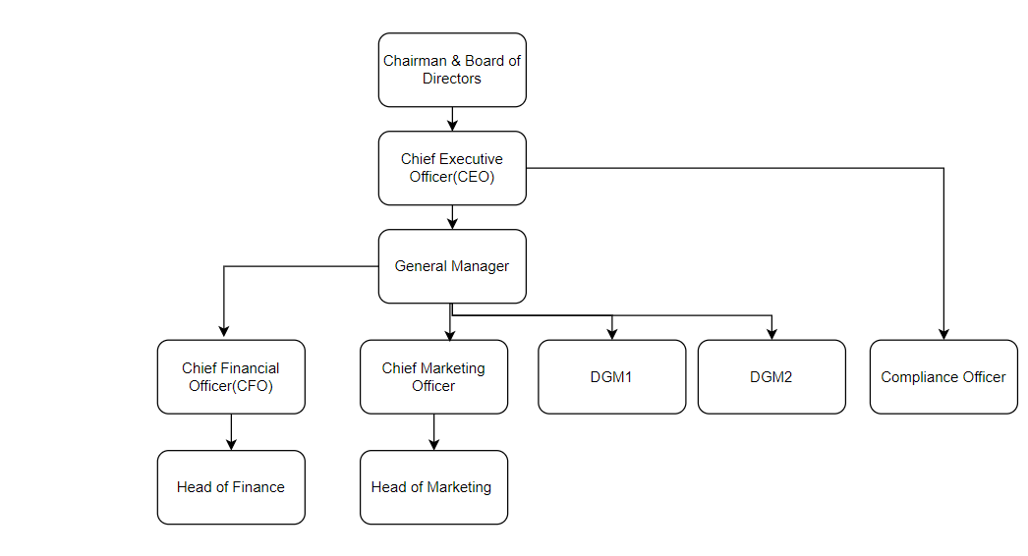

ANNEXURE 4

INFORMATION RELATING TO DIRECTORS

Name in Full | NIC/ Passport No. | Residential Address | Status (chairperson/executive/non-executive) | Directorship in listed companies | Shareholding in listed companies | Directorship in Holding Company, Subsidiary/ies, Associate/s, Joint Venture/s, etc. | Directorship in any other company which has made a similar application to the SEC | Directorship in any other company which has been licensed by the SEC

