APPLICATION FOR THE GRANT OF LICENCE AS A CENTRAL DEPOSITORY

TO: CHAIRMAN
SECURITIES AND EXCHANGE COMMISSION OF SRI LANKA.

........................ (name of Applicant) of applies for licence as a Market Institution in the capacity of a Central Depository under the provisions of the Securities and Exchange Commission of Sri Lanka Act, No. 19 of 2021 (the SEC Act) and hereby undertakes, that in the event li icence is granted, to comply with the provisions of the SEC Act, Rules, Regulations and Determinations made thereunder from time to time.

- Registered name and address of the Applicant:
........................................................................................................................…………….
- Mailing address (if different from 1 above):
......................................................................................................................…………….
- Telephone/ Fax No.: ...................................................................................................….
- E-mail address: ..................................................................................................…………..
- Web-site of the Applicant: …………………………………………………………………………………………..
- Details of the contact person:
    - Name and designation: ………………………………………………………………………..
    - Email address: …………………………………………………………….
    - Telephone No.: ……………………………………………………………
- Name to be appeared on the certificate: ……………………………………………………………………….
- Address to be appeared on the certificate: ……………………………………………………………………

- State whether the Applicant is formed and registered under the Companies Act, No. 17 of 1982 or the Companies Act No. 07 of 2007 of Sri Lanka or is a Company incorporated outside Sri Lanka or formed in pursuance of any statute of any foreign country, Royal Charter or Letters Patent or a body corporate established by or under any written law with details relating thereto including the statute under which it is formed and/or registered and the date of such formation and/or registration:
..................................................................................................................……………......

- The Capital Structure of the Applicant Company:
Stated Capital (Rs.):
Shareholders’ Funds (Rs.):
Financial Year End (dd/mm):

- Shareholding Composition

Please provide details of the shareholding in the following format;

Shareholders
Individual | Ordinary |  | Preference |  | Others
 | No. | % | No. | % | No. | %
Corporation | Ordinary |  | Preference |  | Others
 | No. | % | No. | % | No. | %

Provide following details of each of the Applicant's shareholders, who owns, individually or together with any other person acting in concert with such shareholder, exceeding 5% of the company's ordinary share capital:

- Please provide details of individual shareholders in the following format;

Full name of the shareholder | Residential address | Nationality | Identity Card /Passport Number | Occupation

- Please provide details of shareholders who are bodies corporate in the following format;

Name of the Shareholder Entity | Legal Form of Corporation | Country of Incorporation | Country/ies of operations | Date of Incorporation | Principal business activity | Name/s of shareholders who own more than 20% of the ordinary share capital of the Shareholder

- Please provide following details of the ultimate holding company that directly/ indirectly owns the Applicant (if any);

  - Name:

  - Registered office:

  - Country of incorporation:

  - Date of incorporation:

  - Nature of business:

  - Names of existing directors:

  - Names of shareholders who beneficially own, directly or indirectly, 20% or more of the ordinary share capital of the ultimate holding company;

Name of Shareholder in full | Percentage of shares held | Residential address | Nationality | Identity Card /Passport Number | Occupation

- List of names of the Holding Companies, Subsidiary Companies, Associate Companies, Partnerships and Joint Ventures in which the Applicant has an interest (Annexure 1); and

- a tree diagram depicting the following (Annexure 2);
    - group structure,
    - percentage of shareholding of each group member,
    - principal business activities of each group member, and

- organizational chart of the Company including names and designations, as at the date of application (Annexure 3).

- Documentary proof that shareholders of the Applicant who owns, individually or together with any other person acting in concert with such shareholder, exceeding 5% of the Applicant’s ordinary share capital are persons of good financial standing (Annexure 4).

- Information Relating to Directors of the Applicant;

(Please provide details pertaining to Directors of the Applicant in the format given in Annexure 5).

- Are the Directors of the Applicant functioning in the capacity of Directors of any Listed Companies?

(If so, please provide the names of the Listed Companies against the names of the particular Director)

- Are the Directors of the Applicant also Directors of the Holding Company/ Subsidiary/ Associates/ Joint Ventures?

(If so please provide the names of the Companies against the name of the director)

- Are the Directors of the Applicant shareholders of Listed Companies?

(If so, please provide the names of the Listed Companies against the name of the particular Director)
- Are the Directors of the Applicant directors of another company which has also made a similar application to the Securities and Exchange Commission of Sri Lanka to carry on the identical business as in the present application?

(If so, please provide the name of the company against the name of the particular Director)

- Are the Directors of the Applicant directors of another company which carries on any business which has been licensed by the Securities and Exchange Commission of Sri Lanka?

(If so please provide the name of the company and the nature of business against the name of the particular Director)

- Whether the Directors of the Applicant are/ have been directors of a company that has applied for approval from the SEC to be licensed as a Market Institution/ Intermediary and has been rejected by the SEC?
(If so, please provide details including the name of the company and the type of rejected licence application against the name of the particular Director).

- Whether the Directors of the Applicant are/ have been directors of a company licensed by the SEC which has failed to cease its business operations or to renew its licence in terms of the applicable Rules of the SEC?
(If so, please provide details including the name of the company and the type of licence held against the name of the particular Director).

- Please state whether any Director of the Applicant

- has been convicted, whether within or outside Sri Lanka of an offence involving fraud or dishonesty or the conviction of which involved a finding that he/ she has acted fraudulently or dishonestly;

- has been convicted of an offence under the SEC Act;

- during a period of three years immediately preceding his/ her appointment has been subject to any administrative sanction by the Commission under the SEC Act;

- has been convicted of an offence involving moral turpitude;

- is likely to have a conflict of interest;

- is an undischarged bankrupt whether within or outside Sri Lanka;

- has a judgment debt against him/ her which has not been satisfied in whole or in part.

General Information regarding the Applicant

  - Has there been any judgment by a court of law in respect of any findings of fraud or other dishonest act, misrepresentation, breach of contract, breach of fiduciary duty or professional negligence against the Applicant in any criminal/civil proceedings, or are there any proceedings now pending in a court of law?
…………………………………………………………………………………………………………………………….. (if so, please provide details)

  - Has there been/is there a receiver/ manager/ liquidator or an equivalent person appointed in respect of any of the assets of the Applicant?
………………………………………………………………………………………………………………………………. (if so, please provide details)

  - Has there been/is there a Petition presented in a Court for winding up of the Applicant?
………………………………………………………………………………………………………………………………. (if so, please provide details)

  - Has there been/is there a judgment debt against the Applicant which has not been satisfied in whole or in part?
………………………………………………………………………………………………………………………………. (if so, please provide details)

  - Has the Applicant entered into a compromise or a scheme of arrangement with its creditors?
………………………………………………………………………………………………………………………………. (if so, please provide details)

  - Has the Applicant been subjected to any form of disciplinary proceedings or action by any professional or regulatory body?
………………………………………………………………………………………………………………………………. (if so, please provide details)

  - Has the Applicant applied for approval from the SEC to be licensed as a Market Institution and been rejected by the SEC?
……………………………………………………………………………………………………………………………………
(If so, please provide details)

  - Whether the Applicant is a company licensed by the SEC which has failed to cease its business operations or to renew its licence in terms of the applicable Rules of the SEC?
……………………………………………………………………………………………………………………………………
(If so, please provide details)

- Please provide details pertaining to licence status of any other regulated activities of the Applicant

Regulatory authority | Nature of the licence obtained | Validity period

Documents relating to Incorporation

The application comprises of the following documents which are duly authenticated as true copies of the original.
- Copy of the Memorandum/ Articles of Association or corresponding documents (Annexure 6);
- Copy of the Certificate of Incorporation and the Certificate to Commence Business, if any, or corresponding documents (Annexure 7);
- Documents Relating to Financial and Operational Requirements

- Audited financial statements (for the immediately preceding (3) years or in the event the Applicant has not been in business for three years the latest interim audited financial statements (Annexure 8);
- Details on other business activities of the Applicant (Annexure 9);
- Documents to establish the source of funding to establish the Central Depository (Annexure 10);
- Documents outlining the business model to carry on the function of a Central Depository including financial feasibility (Annexure 11);
- Documents outlining the governance structure (Annexure 12);
- Documents outlining the procedure in relation to the admission of Depository Participants to the Central Depository (Annexure 13);
- Declaration by the Applicant as per the specimen contained in Schedule I of the Rules Applicable to a Central Depository (Annexure 14);
- A copy of the internal compliance manual as specified in Schedule IV of the Rules Applicable to a Central Depository (Annexure 15);
- A copy of the draft Rules of the Applicant in conformity with the requirements set out in Section 55 (3) of the SEC Act (Annexure 16);
- Documentation in support of measures taken to acquire infrastructure and meet related requirements as specified in Rule 24 of the Rules Applicable to a Central Depository (Annexure 17);
- Documentation in support of steps taken to recruit adequate human resources as stated in Rule 48 of the Rules Applicable to a Central Depository to effectively discharge the obligations in keeping with the identified organizational structure of the Applicant (Annexure 18).

- Processing fees

Cheque No. ...........dated .......................for Rs................is attached, being processing fees.
(If the payment was done by a fund transfer, attach the scanned copy of the fund transfer receipt as proof of payment)

We declare that all information provided herein is true and correct and that all attachments are individually certified as being true copies and correct.

………………………………………….. …………………………………………………….
NAME & SIGNATURE OF DIRECTOR NAME & SIGNATURE OF DIRECTOR/COMPANY SECRETARY

DATE ………………..

GRANT OF LICENCE AS A CENTRAL DEPOSITORY

ANNEXURE | DOCUMENT TITLE | DOCUMENTS RELATED TO THE TITLE DOCUMENT
Annexure 1 | RELATED COMPANIES | Details of;  - Holding Company  - Subsidiary Companies  - Associate Companies  - Partnerships  - Joint Ventures
Annexure 2 | GROUP STRUCTURE | Tree diagram of:  - Group Structure  - Percentage of shareholding of each group member  - Principal business activities of each group member
Annexure 3 | ORGANIZATIONAL CHART | Organizational Chart of the Company including names and designations of the responsible individuals
Annexure 4 | FINANCIAL STANDING OF SHAREHOLDERS OF THE APPLICANT | Documentary proof that shareholders of the Applicant who owns, individually or together with any other person acting in concert with such shareholder, exceeding 5% of the Applicant’s ordinary share capital are persons of sound financial standing.  - Audited financial statements for a body corporate  - Affidavit for an individual
Annexure 5 | INFORMATION RELATING TO DIRECTORS | - Name and address  - Status-chairman/executive/non-executive  - Directorships in listed companies  - Directorships in Holding company, subsidiary company/ies, associate company/ies, partnerships/ joint ventures  - Shareholding in listed companies  - Directorships in any other company which has made a similar application to the SEC  - Directorships in any other company which has been licensed by the SEC
Annexure 6 | MEMORANDUM/ARTICLES OF ASSOCIATION | Memorandum/ Articles of Association
Annexure 7 | CERTIFICATE OF INCORPORATION AND COMMENCE BUSINESS | Certificate of Incorporation and Certificate to commence business
Annexure 8 | AUDITED FINANCIAL STATEMENTS | - Audited Financial Statements for the preceding 3 years including  - Statement of Profit or Loss and other comprehensive income  - Statement of financial position  - Statement of changes in equity  - Cash flow statement  - Notes to the financial statements  - Independent Auditor’s report  - If not in operation for 3 years, latest available interim audited financial statements
Annexure 9 | OTHER BUSINESS ACTIVITIES | Details on other business activities of the Applicant
Annexure 10 | SOURCE OF FUNDING | Documents to establish the source of funding to establish the Central Depository
Annexure 11 | BUSINESS MODEL | A comprehensive and detailed proposal including inter alia the following:  - Documents outlining the business model to carry on the functions of a Central Depository (including transaction flow charts or diagrams)  - Proposed revenue sources  - Business plan for the next five years with the execution plan and time lines  - financial projection for 5 years (including financial projections on the resources available to maintain the market facilities)  - Risk management policy that provides for identification and classification of risks and a framework for management and mitigation of the identified risks  - Disaster recovery plan and the Business Continuity Plan (detailing business continuity measures in place to manage operational and business risks and contingencies available in the event of any system malfunction, or the occurrence of emergencies such as disasters etc.)  - Value proposition for the overall development of the capital market
Annexure 12 | GOVERNANCE STRUCTURE | - Documents outlining the governance structure  - Board Charter that interalia includes a Code of Conduct for the Board of Directors demarcating the responsibilities between its Board of Directors and Management  - Details of the sub-committees of the Board of the Applicant
Annexure 13 | ADMISSION OF DEPOSITORY PARTICIPANTS | Documents outlining the procedure in relation to the admission of Depository Participants to the Central Depository
Annexure 14 | DECLARATION BY THE APPLICANT | This must be as per the specimen contained in Schedule I of the Rules Applicable to a Central Depository
Annexure 15 | INTERNAL COMPLIANCE MANUAL | This must be as specified in Schedule IV of the Rules Applicable to a Central Depository
Annexure 16 | CENTRAL DEPOSITORY RULES | A copy of the draft Rules in conformity with the requirements set out in Section 55 (3) of the SEC Act.
Annexure 17 | INFRASTRUCTURE AND OTHER RELATED REQUIREMENTS | Documentation in support of measures taken to acquire infrastructure and meet related requirements as specified in Rule 24 of the Rules Applicable to a Central Depository
Annexure 18 | HUMAN RESOURCES | Documentation in support of steps taken to recruit adequate human resources as stated in Rule 48 of the Rules Applicable to a Central Depository to effectively discharge the obligations in keeping with the identified organizational structure of the Applicant.

ANNEXURE 1

RELATED COMPANIES

HOLDING COMPANY | SUBSIDIRARY COMPANIES | ASSOCIATE COMPANIES | PARTNERSHIPS | JOINT VENTURES

ANNEXURE 2

GROUP STRUCTURE

Principal Business Activity
%
Holding Company
Subsidiary 02

Associate 02

Associate 01
Subsidiary 01

%

%

%

%

Principal Business Activity
Principal Business Activity
Principal Business Activity
Principal Business Activity

ANNEXURE 3

ORGANIZATIONAL CHART

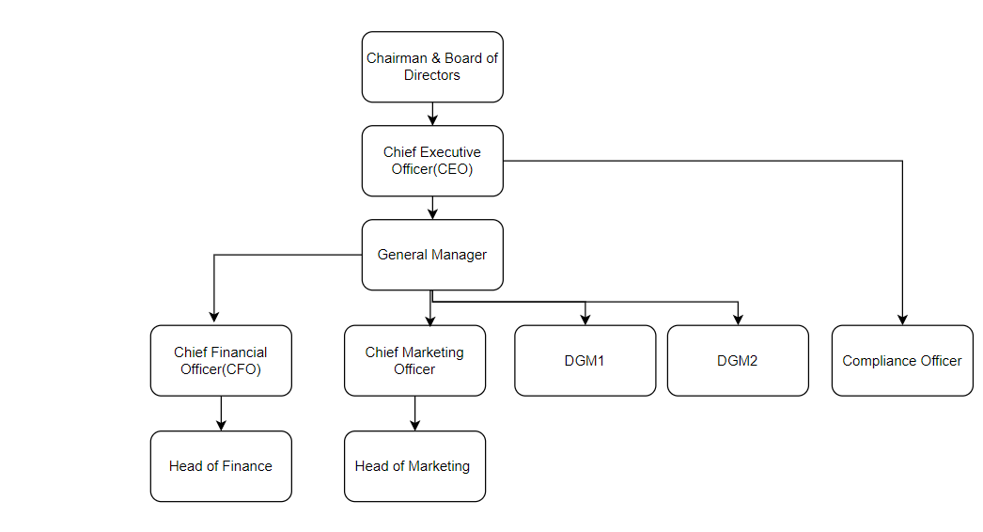

ANNEXURE 5

INFORMATION RELATING TO DIRECTORS

Name in Full | NIC/ Passport No. | Residential Address | Status (chairperson/executive/non-executive) | Directorship in listed companies | Shareholding in listed companies | Directorship in Holding Company, Subsidiary/iesAssociate/s,  Partnerships,  Joint Ventures | Directorship in any other company which has made a similar application to the SEC | Directorship in any other company which has been licensed by the SEC

ANNEXURE 14
Declaration by the Applicant

To: Chairman
Securities and Exchange Commission of Sri Lanka
Level 28 & 29, East Tower
World Trade Center
Echelon Square, Colombo 01, Sri Lanka.

In consideration of being licenced to operate as (type of market institution), we (name of the applicant entity) being duly incorporated and having our registered office/ principal place of business at …(address)….. hereby undertake and agree:

- to be licenced at the sole discretion of the Commission and for such period as may be determined by the SEC; and

- to be bound by the applicable Laws, Rules, Regulations and Directives of the Commission as amended or replaced from time to time.

We further declare that no finding has been made against the Applicant/the Applicant entity by a court of law in Sri Lanka or abroad for the commission of any criminal offence/ capital market offence or any other act which involves fraud, deceit, dishonesty, misrepresentation, breach of contract or breach of fiduciary duty and that the statements made and information provided are true and accurate to the best of my knowledge.

Given under the Common Seal of the Entity on this …. day of …. in the presence of

……………………….
(Name) Director

……………………..
(Name) Director/Secretary
Or,
Signed by the duly authorized signatories of the Entity on this …. day of …..

…………………………
(Name) Authorized Signatory

Note: Please attach a certified true copy of the Board Resolution/Power of Attorney in proof of such authority.

